The sketch of hyperelastic seal structure is shown as follows:
Y ring
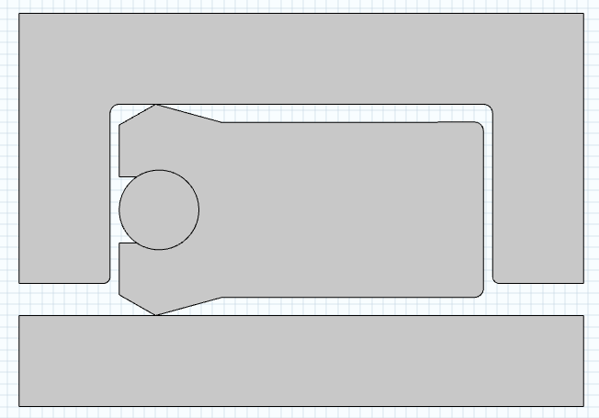
Cylinder

O ring

Piston

Details are as follows:

1. Global Parameters
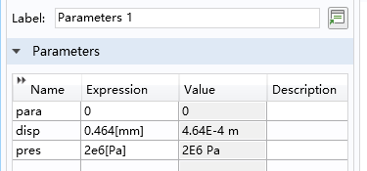
2. Three contact pairs:
(1) All boundaries of Y ring with all boundaries of O ring (Friction included)
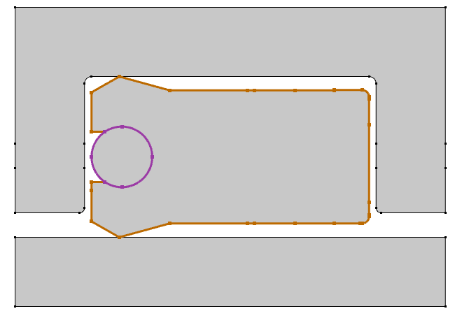

(2) All boundaries of Y ring with all boundaries of Cylinder (Friction included)
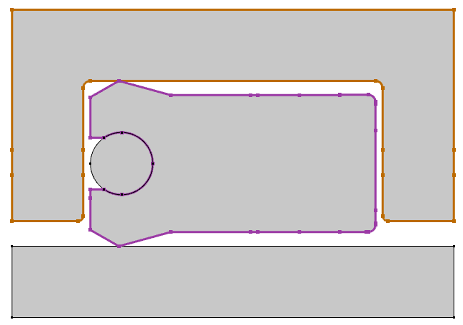
(3) All boundaries of Y ring with all boundaries of Piston (Friction included)
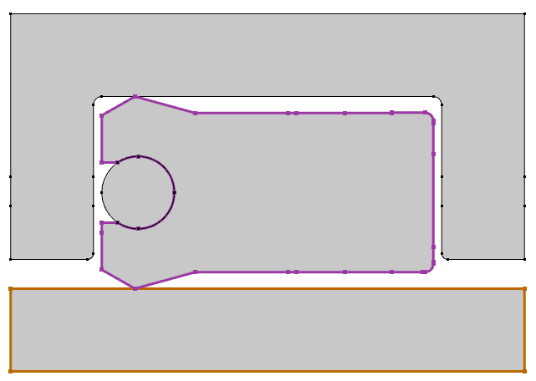

3. Initial conditions

(1)
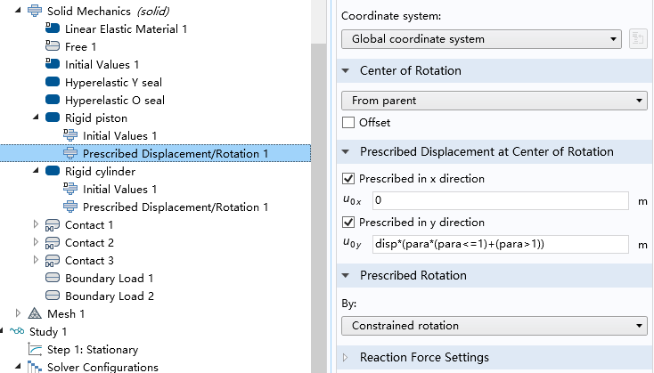
(2)
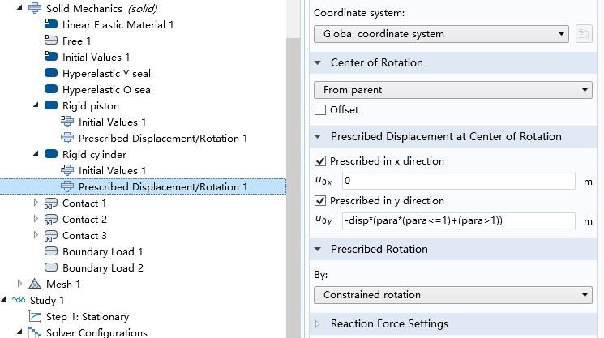

(3)

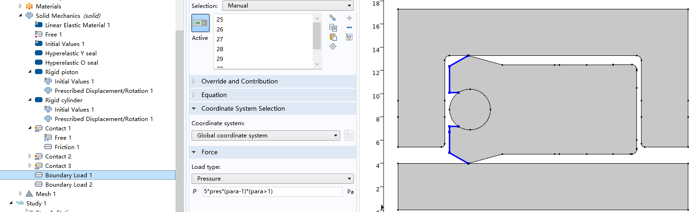

(4)
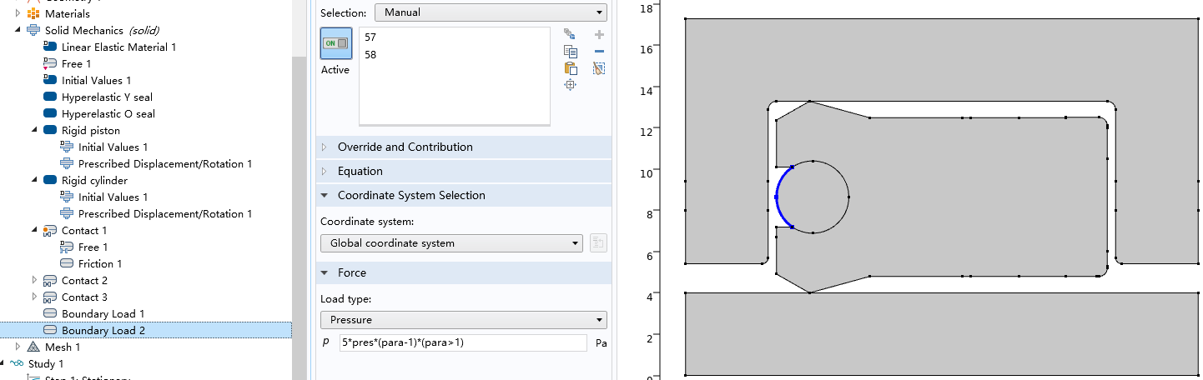
4. Something wrong with the results

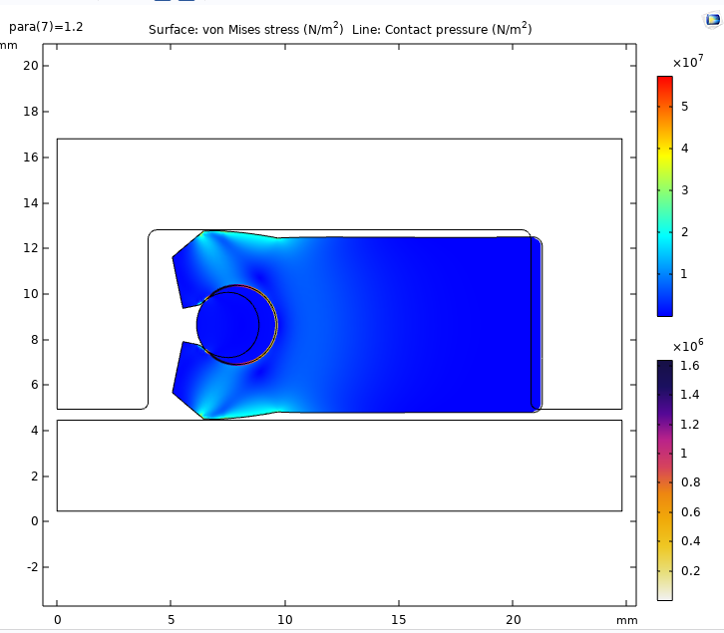

Boundary A
(The right boundary of Y ring)
Boundary B
(The right boundary of the internal boundaries of Cylinder)

Problem:

Because of boundaries loads (pressure, shown in Initial conditions (3) and (4)), the Y ring and O ring both moved rightwards.

But the boundary A (the right boundary of Y ring) moved beyond the boundary B (the right boundary of the internal boundaries of Cylinder).

Generally, boundary A (the right boundary of Y ring) should not move beyond boundary B (the right boundary of the internal boundaries of Cylinder), and the critical condition is that boundary A overlaps boundary B.

Is there something wrong with the Initial conditions?
Can someone help me to deal with it?
Your suggestions are highly appreciated!

